**MODULE: 4**

**Practical-1: Write a program to demonstrate different Window handling events.**

import java.awt.*;

import java.awt.event.WindowEvent;

import java.awt.event.WindowListener;

public class OneWindowListener extends Frame implements WindowListener {

OneWindowListener() {

addWindowListener(this);

setSize (400, 400);

setLayout (null);

setVisible (true);

}

public static void main(String[] args) {

new OneWindowListener();

}

public void windowActivated (WindowEvent arg0) {

System.out.println("activated");

}

public void windowClosed (WindowEvent arg0) {

System.out.println("closed");

}

public void windowClosing (WindowEvent arg0) {

System.out.println("closing");

dispose();

}

public void windowDeactivated (WindowEvent arg0) {

System.out.println("deactivated");

}

public void windowDeiconified (WindowEvent arg0) {

System.out.println("deiconified");

}

public void windowIconified(WindowEvent arg0) {

System.out.println("iconified");

}

public void windowOpened(WindowEvent arg0) {

System.out.println("opened");

}

}

**Output:**

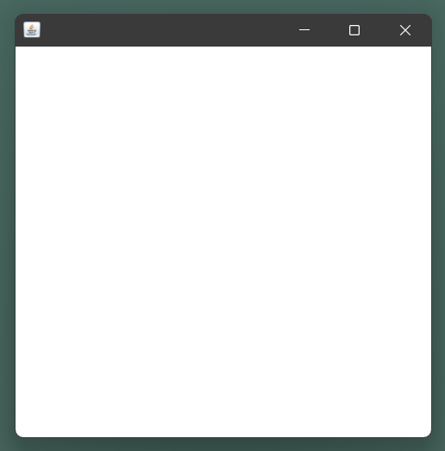

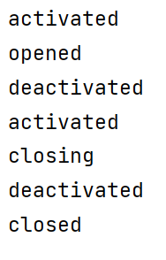

**Practical-2: Write a program to demonstrate different mouse handling events like mouseClicked(), mouseEntered(), mouseExited(), mousePressed, mouseReleased() and mouseDragged().**

**// Mouse Listener**

import java.awt.*;

import java.awt.event.*;

public class TwoMouseListener extends Frame implements MouseListener{

Label l;

TwoMouseListener(){

addMouseListener(this);

l=new Label();

l.setBounds(20,50,300,300);

add(l);

setSize(500,500);

setLayout(null);

setVisible(true);

}

public static void main(String[] args) {

new TwoMouseListener();

}

public void mouseClicked(MouseEvent e) {

l.setText("Mouse Clicked at " + e.getX() + " " + e.getY());

System.out.println(getAlignmentX() + " " + getAlignmentY());

}

public void mousePressed(MouseEvent e) {

l.setText("Mouse Pressed at " + getX() + " " + getY());

System.out.println(getAlignmentX() + " " + getAlignmentY());

}

public void mouseEntered(MouseEvent e) {

l.setText("Mouse Entered");

}

public void mouseExited(MouseEvent e) {

l.setText("Mouse Exited");

}

public void mouseReleased(MouseEvent e) {

l.setText("Mouse Released");

}

}

**Output:**

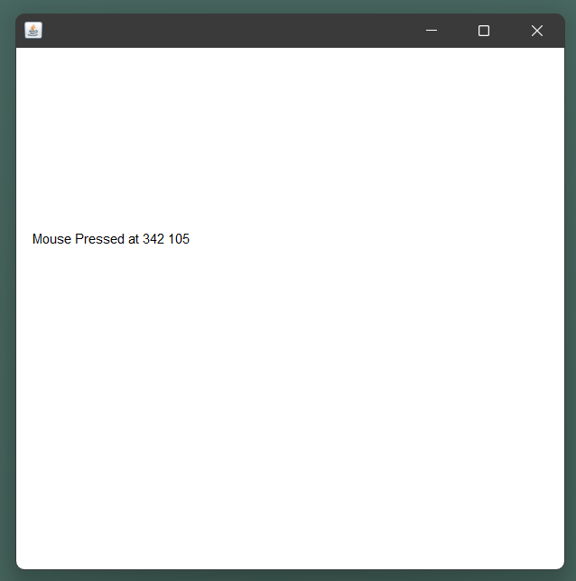 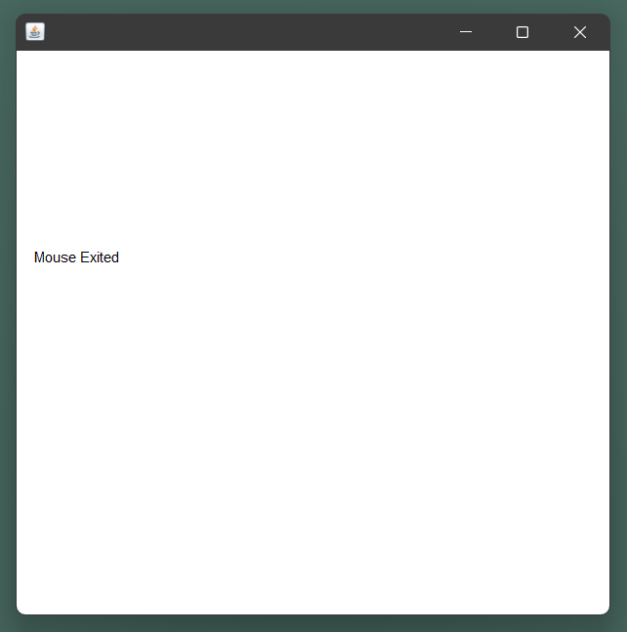

**// MouseMotionListener**

import java.awt.*;

import java.awt.event.*;

public class TwoMouseMotionListener extends Frame implements MouseMotionListener{

Label l;

TwoMouseMotionListener(){

addMouseMotionListener(this);

l=new Label();

l.setBounds(20,50,100,20);

add(l);

setSize(500,500);

setLayout(null);

setVisible(true);

}

public static void main(String[] args) {

new TwoMouseMotionListener();

}

public void mouseDragged(MouseEvent e) {

Graphics g=getGraphics();

g.setColor(Color.RED);

g.fillOval(e.getX(),e.getY(),20,20);

}

public void mouseMoved(MouseEvent e) {

l.setText("mouse is moved to point " + e.getX() + " " + e.getY());

}

}

**Output:**

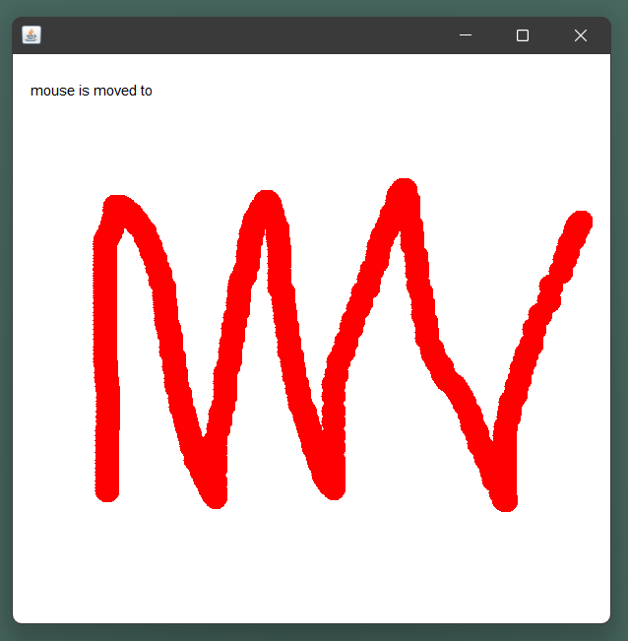

**Practical-3: Write a program to demonstrate different keyboard handling events.**

import java.awt.*;

import java.awt.event.*;

public class ThreeKeyListener extends Frame implements KeyListener {

Label l;

TextArea area;

ThreeKeyListener() {

l = new Label();

l.setBounds(20, 50, 100, 20);

area = new TextArea();

area.setBounds(20, 80, 300, 300);

area.addKeyListener(this);

add(l);

add(area);

setSize(400, 400);

setLayout(null);

setVisible(true);

}

public void keyPressed(KeyEvent e) {

l.setText("Key Pressed");

}

public void keyReleased(KeyEvent e) {

l.setText("Key Released");  **Output**

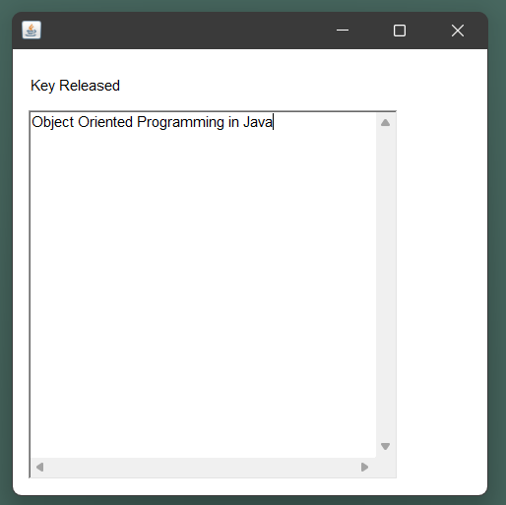 }

public void keyTyped(KeyEvent e) {

l.setText("Key Typed");

}

public static void main(String[] args) {

new ThreeKeyListener();

}

}

**Practical-4: Write a program to generate a window without an applet window using main() function.**

import java.awt.Frame;

public class FourApplet extends Frame{

FourApplet(String title){

super();

this.setTitle(title);

this.setVisible(true);

}

public static void main(String args[]){

FourApplet window = new FourApplet("Create Window Example");

}

}

**Output:**

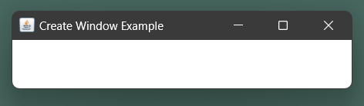

**Practical-5: Write a program to demonstrate the use of push buttons.**

import java.awt.*;  
import java.awt.event.*;  
import javax.swing.*;  
  
public class FivePush {  
 public static void main(String[] args) {  
 final JFrame frame = new JFrame();  
 JButton btnOK = new JButton("OK");  
 btnOK.addActionListener(  
 new ActionListener(){  
 public void actionPerformed(ActionEvent e) {  
 JOptionPane.*showMessageDialog*(frame,"You've clicked OK button");  
 }  
 });  
 JButton btnCancel = new JButton("Cancel");  
 btnCancel.addActionListener(  
 new ActionListener(){  
 public void actionPerformed(ActionEvent e) {  
 JOptionPane.*showMessageDialog*(frame,"You've clicked Cancel button"  
 );  
 }  
 });  
 JPanel buttonPanel = new JPanel( );  
 buttonPanel.add(btnOK);  
 buttonPanel.add(btnCancel);  
 frame.setDefaultCloseOperation(JFrame.*EXIT_ON_CLOSE*);  
 frame.setSize(300, 200);  
 frame.getContentPane( ).add(buttonPanel,BorderLayout.*SOUTH*);  
 frame.setVisible(true);  
 }  
}

**Output:**

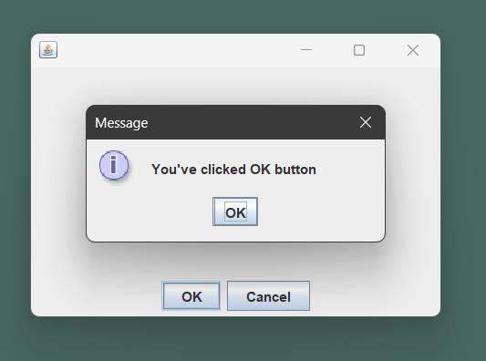

**Practical-6: WAP to create a Menu using the frame.**

import java.awt.*;

class MenuExample {

MenuExample(){

Frame f= new Frame("NetBeans IDE");

MenuBar mb=new MenuBar();

// File Menu

Menu menu=new Menu("File");

Menu submenu=new Menu("New");

MenuItem i1=new MenuItem("New Project");

MenuItem i2=new MenuItem("New File");

MenuItem i3=new MenuItem("Open");

MenuItem i4=new MenuItem("Save");

MenuItem i5=new MenuItem("Print");

submenu.add(i1);

submenu.add(i2);

menu.add(submenu);

menu.add(i3);

menu.add(i4);

menu.add(i5);

mb.add(menu);

// Run Menu

Menu Run=new Menu("Run");

MenuItem run=new MenuItem("Run Main");

MenuItem debug=new MenuItem("Debug");

Run.add(run);

Run.add(debug);

mb.add(Run);

f.setMenuBar(mb);

f.setSize(300,200);

f.setLayout(null);

f.setVisible(true);

}

public static void main(String args[]) {

new MenuExample();

}

}

**Output:**

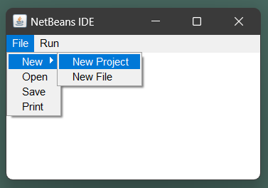 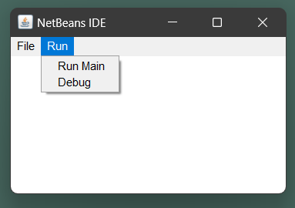

**Practical-7: WAP to create a Frame that display the student information.**

import javax.swing.*;

import java.awt.event.*;

import java.io.*;

public class SevenStudent {

public static void StudentInfo() {

JFrame f = new JFrame("Student Details Form");

JLabel l1, l2, l3, l4, l5;

JTextField t1, t2, t3;

JComboBox j1, j2;

JButton b1, b2;

l1 = new JLabel("Student Name:");

l1.setBounds(50, 50, 100, 30);

l2 = new JLabel("College Email ID:");

l2.setBounds(50, 120, 120, 30);

l3 = new JLabel("Branch:");

l3.setBounds(50, 190, 50, 30);

l4 = new JLabel("Group:");

l4.setBounds(420, 50, 70, 60);

l5 = new JLabel("Mobile No:");

l5.setBounds(420, 120, 70, 30);

t1 = new JTextField();

t1.setBounds(150, 50, 130, 30);

t2 = new JTextField();

t2.setBounds(160, 120, 130, 30);

t3 = new JTextField();

t3.setBounds(490, 120, 130, 30);

String s1[] = { " ", "CSE", "ECE", "EEE", "CIVIL", "MEC", "Others" };

String s2[] = { " ", "G1", "G2", "G3", "G4", "G5", "G6", "G7", "G8", "G9", "G10", "G11", "G12" };

j1 = new JComboBox(s1);

j1.setBounds(120, 190, 100, 30);

j2 = new JComboBox(s2);

j2.setBounds(470, 50, 140, 30);

b1 = new JButton("Save");

b1.setBounds(150, 300, 70, 30);

b2 = new JButton("close");

b2.setBounds(420, 300, 70, 30);

b1.addActionListener(new ActionListener() {

public void actionPerformed(ActionEvent e) {

String s1 = t1.getText();

String s2 = t2.getText();

String s3 = j1.getSelectedItem() + "";

String s4 = j2.getSelectedItem() + "";

String s5 = t3.getText();

if (e.getSource() == b1) {

try {

FileWriter w= new FileWriter("StudentDetails.txt", true);

w.write(s1 + "\n");

w.write(s2 + "\n");

w.write(s3 + "\n");

w.write(s4 + "\n");

w.write(s5 + "\n");

w.close();

}

catch (Exception ae) {

System.out.println(ae);

}

}

JOptionPane.showMessageDialog(f,"Successfully Saved" + " The Details");

}

});

b2.addActionListener(new ActionListener() {

public void actionPerformed(ActionEvent e)

{

f.dispose();

}

});

f.addWindowListener(new WindowAdapter() {

public void windowClosing(WindowEvent e)

{

System.exit(0);

}

});

f.add(l1);

f.add(t1);

f.add(l2);

f.add(t2);

f.add(l3);

f.add(j1);

f.add(l4);

f.add(j2);

f.add(l5);

f.add(t3);

f.add(b1);

f.add(b2);

f.setLayout(null);

f.setSize(700, 600);

f.setVisible(true);

}

public static void main(String args[]) {

StudentInfo();

}

}

**Output:**

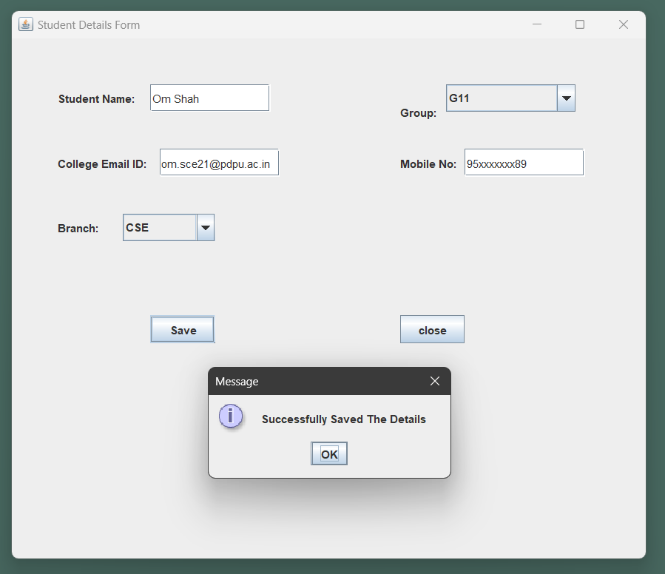

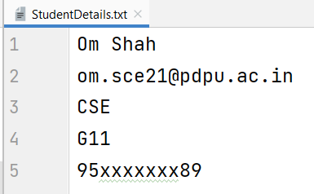

**Practical-8: WAP to create a Dialogbox.**

import java.awt.event.*;

import javax.swing.*;

class DialogueClass extends JFrame implements ActionListener {

JButton b1;

DialogueClass() {

this.setLayout(null);

b1 = new JButton("Button 2");

b1.setBounds(130, 05, 100, 50);

this.add(b1);

b1.addActionListener(this);

}

public void actionPerformed(ActionEvent evt) {

if (evt.getSource() == b1) {

JOptionPane.showMessageDialog(this, "Enter a valid String", "WARNING", JOptionPane.WARNING_MESSAGE);

}

}

}

class EightDialogue {

public static void main(String args[]) {

DialogueClass f = new DialogueClass(); **Output**

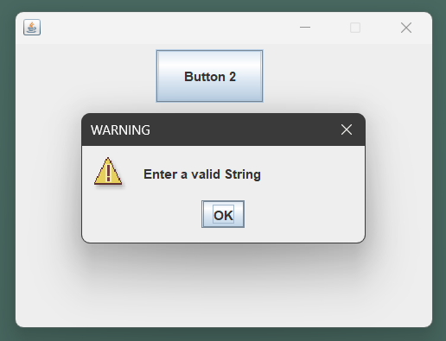 f.setBounds(200, 200, 400, 300);

f.setResizable(false);

f.setVisible(true);

}

}

**Practical-9: WAP to implement the FlowLayout and BorderLayout.**

**// Flow Layout**

import java.awt.*;

import javax.swing.*;

class Layout extends JFrame {

JLabel l1, l2, l3, l4, l5;

public Layout() {

setDefaultCloseOperation(JFrame.EXIT_ON_CLOSE);

FlowLayout layout = new FlowLayout();

this.setLayout(layout);

l1 = new JLabel("Label 1 ");

l2 = new JLabel("Label 2 ");

l3 = new JLabel("Label 3 ");

l4 = new JLabel("Label 4 ");

l5 = new JLabel("Label 5 ");

this.add(l1);

this.add(l2);

this.add(l3);

this.add(l4);

this.add(l5);

}

}

class NineFlowLayout {

public static void main(String[] args) {

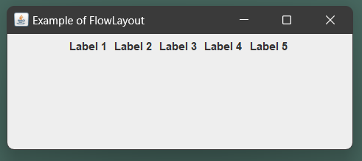 Layout f = new Layout(); **Output**

f.setTitle("Example of FlowLayout");

f.setBounds(200, 100, 600, 400);

f.setVisible(true);

}

}

**// Border Layout**

import java.awt.*;

import javax.swing.*;

class BoderLayoutDemo extends JFrame {

BoderLayoutDemo() {

JPanel pa = new JPanel();

pa.setLayout(new BorderLayout());

pa.add(new JButton("Welcome"), BorderLayout.NORTH);

pa.add(new JButton("OOP"), BorderLayout.SOUTH);

pa.add(new JButton("Layout"), BorderLayout.EAST);

pa.add(new JButton("Border"), BorderLayout.WEST);

pa.add(new JButton("Java"), BorderLayout.CENTER);

add(pa);

setDefaultCloseOperation(JFrame.EXIT_ON_CLOSE);

setSize(300, 300);

setVisible(true);

}

} **Output**

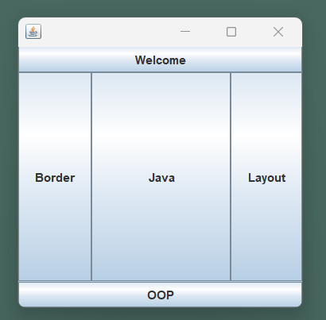

class NineBorderLayout {

// Driver code

public static void main(String[] args) {

new BoderLayoutDemo();

}

}

**Practical-10: WAP to implement the GridLayout and CardLayout.**

**// Grid Layout**

import javax.swing.*;

import java.awt.*;

public class TenGridLayout extends JFrame {

TenGridLayout() {

JPanel p1 = new JPanel();

p1.setLayout(new GridLayout(4, 2));

FlowLayout layout = new FlowLayout();

JPanel p2 = new JPanel();

p2.setLayout(layout);

JLabel one, two, three, four;

JTextField tname, tsalary, tcode, tdesig;

JButton buttonSave, buttonExit;

one = new JLabel("NAME");

tname = new JTextField(20);

two = new JLabel("CODE");

tcode = new JTextField(20);

three = new JLabel("DESIGNATION");

tdesig = new JTextField(20);

four = new JLabel("SALARY");

tsalary = new JTextField(20);

buttonSave = new JButton("SAVE");

buttonExit = new JButton("EXIT");

p1.add(one);

p1.add(tname);

p1.add(two);

p1.add(tcode);

p1.add(three);

p1.add(tdesig);

p1.add(four);

p1.add(tsalary);

p2.add(buttonSave);

p2.add(buttonExit);

add(p1, "North");

add(p2, "South");

setVisible(true);

this.setSize(400, 180);

}

public static void main(String args[]) {

new TenGridLayout();

}

}

**Output:**

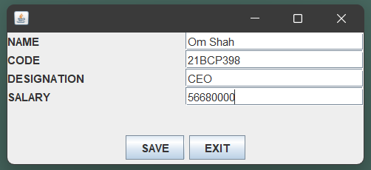

**// Card Layout**

import java.awt.*;

import java.awt.event.*;

import javax.swing.JFrame;

import javax.swing.*;

public class TenCardLayout extends JFrame implements ActionListener {

CardLayout card;

JButton b1, b2, b3;

Container c;

TenCardLayout(){

c = getContentPane();

card = new CardLayout(40, 30);

c.setLayout(card);

b1 = new JButton("OBJECT");

b2 = new JButton("ORIENTED");

b3 = new JButton("PROGRAMMING");

b1.addActionListener(this);

b2.addActionListener(this);

b3.addActionListener(this);

c.add("a", b1);

c.add("b", b2);

c.add("c", b3);

}

public void actionPerformed(ActionEvent e) {

card.next(c);

}

public static void main(String[] args) {

TenCardLayout cl = new TenCardLayout();

cl.setSize(400, 400);

cl.setVisible(true);

cl.setDefaultCloseOperation(EXIT_ON_CLOSE);

}

}

**Output:**

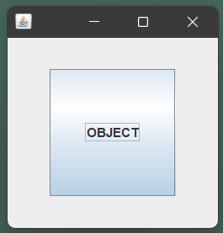 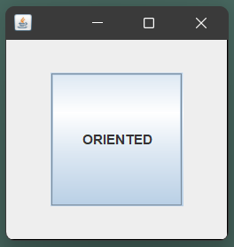 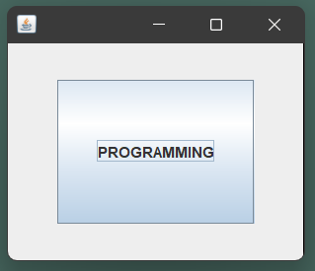

**Practical-11: WAP to implement the GroupLayout and BoxLayout.**

**// Group Layout**

import java.awt.*;

import java.awt.event.*;

import javax.swing.*;

public class ElevenGroupLayout {

private JFrame mainFrame;

private JLabel headerLabel, statusLabel, msglabel;

private JPanel controlPanel;

public ElevenGroupLayout(){

prepareGUI();

}

public static void main(String[] args){

ElevenGroupLayout GroupLayoutDemo = new ElevenGroupLayout();

GroupLayoutDemo.showGroupLayoutDemo();

}

private void prepareGUI(){

mainFrame = new JFrame("Java GroupLayout Examples");

mainFrame.setSize(400, 400);

mainFrame.setLayout(new GridLayout(3, 1));

headerLabel = new JLabel("", JLabel.CENTER);

statusLabel = new JLabel("", JLabel.CENTER);

statusLabel.setSize(350, 100);

mainFrame.addWindowListener(new WindowAdapter(){

public void windowClosing(WindowEvent windowEvent)

{

System.exit(0);

}

});

controlPanel = new JPanel();

controlPanel.setLayout(new FlowLayout());

mainFrame.add(headerLabel);

mainFrame.add(controlPanel);

mainFrame.add(statusLabel);

mainFrame.setVisible(true);

}

private void showGroupLayoutDemo(){

headerLabel.setText("Layout in action: GroupLayout");

JPanel panel = new JPanel();

panel.setSize(200, 200);

GroupLayout layout = new GroupLayout(panel);

layout.setAutoCreateGaps(true);

layout.setAutoCreateContainerGaps(true);

JButton btn1 = new JButton("Button 1");

JButton btn2 = new JButton("Button 2");

JButton btn3 = new JButton("Button 3");

layout.setHorizontalGroup(layout.createSequentialGroup()

.addComponent(btn1)

.addGroup(layout.createSequentialGroup()

.addGroup(layout.createParallelGroup(GroupLayout.Alignment.LEADING)

.addComponent(btn2)

.addComponent(btn3))));

layout.setVerticalGroup(layout.createSequentialGroup()

.addComponent(btn1) **Output**

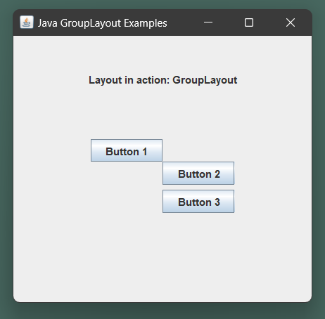 .addComponent(btn2)

.addComponent(btn3));

panel.setLayout(layout);

controlPanel.add(panel);

mainFrame.setVisible(true);

}

}

**// Box Layout**

import javax.swing.JFrame;

import javax.swing.JButton;

import javax.swing.BoxLayout;

import javax.swing.JPanel;

import javax.swing.border.EmptyBorder;

import java.awt.Insets;

public class ElevenBoxLayout {

public static void main(String[] args){

JFrame.setDefaultLookAndFeelDecorated(true);

JFrame frame = new JFrame("BoxLayout Example X_AXIS");

JButton jbtn1, jbtn2, jbtn3, jbtn4, jbtn5;

frame.setDefaultCloseOperation(JFrame.EXIT_ON_CLOSE);

JPanel panel = new JPanel();

BoxLayout boxlayout = new BoxLayout(panel, BoxLayout.X_AXIS);

panel.setLayout(boxlayout);

panel.setBorder(new EmptyBorder(new Insets(100, 150, 100, 150)));

jbtn1 = new JButton("Button 1");

jbtn2 = new JButton("Button 2");

jbtn3 = new JButton("Button 3");

jbtn4 = new JButton("Button 4");

jbtn5 = new JButton("Button 5");

panel.add(jbtn1);

panel.add(jbtn2);

panel.add(jbtn3);

panel.add(jbtn4);

panel.add(jbtn5);

frame.add(panel);

frame.pack();

frame.setVisible(true);

}

}

**Output:**

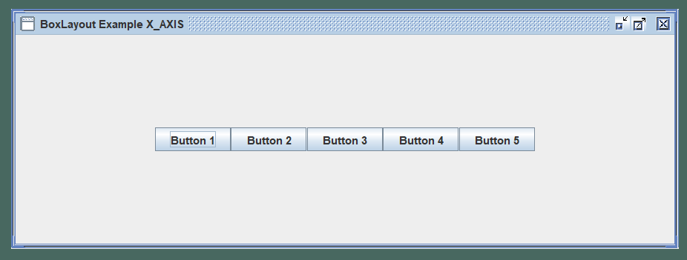

**Practical-12: Write a program that demonstrates the life cycle of an applet.**

import java.applet.Applet;

import java.awt.Graphics;

public class TwelveApplet extends Applet {

public void init() {

System.out.println("In init()");

}

public void start() {

System.out.println("In start()");

}

public void paint(Graphics g) {

System.out.println("In paint()");

}

public void stop() {

System.out.println("In stop()");

}

public void destroy() {

System.out.println("In destroy()");

}

}

**Practical-13: WAP to demonstrate System clock.**

import java.time.*;

public class ThirteenClock {

public static void main(String[] args) {

Clock c = Clock.systemDefaultZone();

System.out.println(c.getZone());

System.out.println(c.instant());

}

}

**Output:**

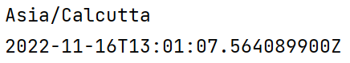

**Practical-14: WAP to demonstrate Painting in applet.**

import java.awt.*;

import javax.swing.*;

class FourteenPaint extends JPanel {

JButton jb;

JTextField jt;

FourteenPaint() {

JFrame app = new JFrame("Application");

app.add(this);

app.setSize(300,300);

app.setLocationRelativeTo(null);

app.setDefaultCloseOperation(JFrame.EXIT_ON_CLOSE);

app.setVisible(true);

}

public void paintComponent(Graphics g){

super.paintComponent(g);

g.setColor(Color.YELLOW);

g.fillOval(10,10,100,100);

}

public static void main(String[] args) {

new FourteenPaint();

}

}

**Output:**

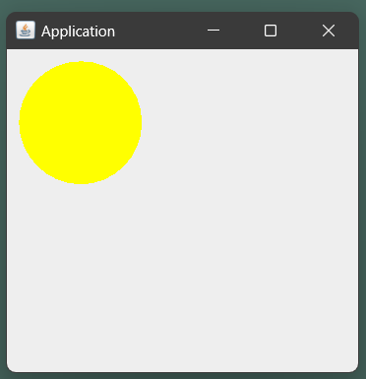

**Practical-15: WAP to demonstrate Graphics in applet.**

import javax.swing.*;

import java.awt.*;

public class FifteenGraphics extends JPanel {

FifteenGraphics() {

JFrame app = new JFrame("Shapes in Graphics in Java");

app.add(this);

app.setSize(400,400);

app.setLocationRelativeTo(null);

app.setDefaultCloseOperation(JFrame.EXIT_ON_CLOSE);

app.setVisible(true);

}

public void paint(Graphics g){

g.setColor(Color.red);

g.drawString("Welcome",50, 50);

g.drawLine(20,30,20,300);

g.drawRect(70,100,30,30);

g.fillRect(170,100,30,30);

g.drawOval(70,200,30,30);

**Output**

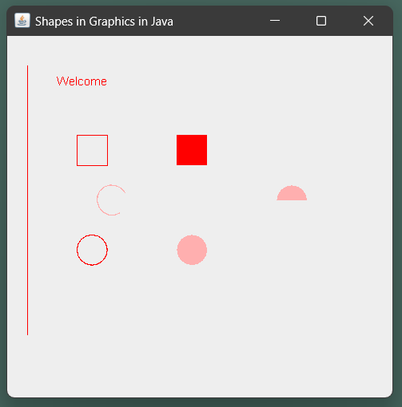 g.setColor(Color.pink);

g.fillOval(170,200,30,30);

g.drawArc(90,150,30,30,30,270);

g.fillArc(270,150,30,30,0,180);

}

public static void main(String[] args) {

new FifteenGraphics();

}

}